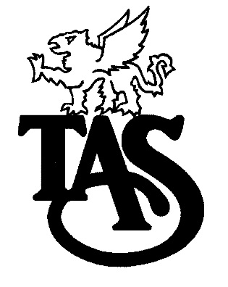
THOMAS A. STEWART
SECONDARY SCHOOL

Specialist High Skills Major

The Specialist High Skills Major (SHSM) is a unique career-focused program option for students. This specialized program allows students to focus their learning on a particular economic sector while meeting the requirements for the Ontario Secondary School Diploma. It also assists in their transition from secondary school to apprenticeship, college, university, or the workplace. Every SHSM includes:
sector-recognized certifications and training courses;
a bundle of Grade 11 and 12 credits;
experiential learning activities within the sector;
"reach ahead" experiences; and,
development of key essential skills and work habits required in the sector.

Specialist High Skills Major in Hospitality and Tourism

This opportunity is for students in their grade 11 and 12 years, and is a specialized program which allows students to experience learning activities in the Hospitality and Tourism Sector while meeting the requirements for the Ontario Secondary School Diploma (OSSD). The SHSM program is a practical and effective way to provide students with specific skills and sector training that will assist in the transition from secondary school to apprenticeship training, college, university or the workplace.

The components of this program are as follows:

The SHSM in Hospitality and Tourism requires students to complete 6 sector-recognized certifications and / or training courses.

Four Compulsory
Cardiopulmonary Resuscitation (CPR) Level C – includes automated external defibrillation (AED) | customer service | Standard First Aid | Workplace Hazardous Materials Information System (WHMIS) – generic (i.e., not site-specific) instruction

Two (2) electives from the list below
advanced training in a technique, (e.g., paddling) | cash handling and register training | compass/map/global positioning system (GPS) | cook/line cook
event coordination | fire safety training | fishing guide | geographic information system (GIS)
guest services | heritage interpreter | housekeeping services | introduction to hospitality management
leadership skills | life saving | safe food handling – advanced | safe food handling – basic
Smart Serve | spa etiquette | spa service | ticket agent
tour guide | tourism – basic | wilderness first aid | wilderness survival

There are 9 required credits:
 | Grade 11 |  | Grade 12
SHSM Hospitality and Tourism Major Subjects  (4 in total; at least one from Gr. 11 and one from Gr. 12) | CHW3M  NBV3C  HSP3C  PAD30  PAF 30  PPL30  SBI3C | TFJ3C  TFJ3E  HSP3U  SVN3E  SCH3U  SBI3U  SBI3C | PPL40  SCH4C  SCH4U  SBI4U  PPL40  CGW4U  CHY4U | PLF 4C  TFJ4C  TFJ4E  TUI4T  HFA4U  HSB4U
English  (1 credit)  Mathematics  (1 credit)  Business or Science  (1 credit) | ENG3C  ENG3E  MBF3C  MCR3U  BAF3M  BMI3C  BTA30  ICS 3C  ICS 3U | OLC 30  ENG3U  MEL3E  MCF3M  SBI3U  SBI3C  SCH3U  SPH3U  SVN3E | ENG4C  ENG4E  MAP4C  MHF4U  MCV4U  BAT4M  BBB4M  ICS 4C  ICS 4U  SNC4M  SBI4U | ENG4U  MCT4C  MDM4U  SCH4U  SCH4C  SPH4U  SPH4C
Co-Op (2 credits) | 2 credits of Co-Op tied to SHSM Sector

