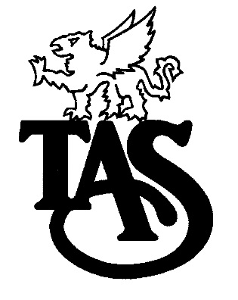
THOMAS A. STEWART
SECONDARY SCHOOL

Specialist High Skills Major

The Specialist High Skills Major (SHSM) program is a unique, career-focused option for students. This specialized program allows students to focus their learning on a particular economic sector while meeting the requirements for the Ontario Secondary School Diploma. It also assists in their transition from secondary school to apprenticeship, college, university, or the workplace. Every SHSM includes:
a bundle of Grade 11 and 12 credits;
sector-recognized certifications and training courses;
experiential learning activities within the sector;
"reach ahead" experiences and career exploration;
development of key essential skills and work habits required in the sector.

Specialist High Skills Major in Arts & Culture

This exciting program allows students to concentrate their creative and artistic skills into four areas of the Arts & Culture sector: instrumental and / or vocal music, visual arts, dance or drama. Through the creation of dramatic, dance, musical productions and / or visual art works and exhibitions, students will develop their skills in the technical, creative, and expressive qualities of the Arts. This unique program is designed for creative individuals in all pathways who may be interested in pursuing employment or further study in any of the following areas: media arts, photography, fine art, graphic design, film, music, theatre studies, dance, and / or dramatic arts. Additionally, SHSM students may concentrate on set building, theatrical costume construction and design, lighting and sound production, as well as theatrical make-up. Students are actively engaged in visual art installations and performance, on stage and backstage, in both the school and the community.

The specific components of this program are described on the reverse side of this paper.

The SHSM in Arts & Culture requires students to complete 6 sector-recognized certifications and / or training courses.

Three Compulsory:
Workplace Hazardous Materials Information System (WHMIS) – Acquired through Co-Op
Standard First Aid – Onsite Training at TAS
CPR, Level C - Onsite Training at TAS

Three Electives: (Choice Provided)
There will be opportunities for students to participate in various workshops and excursions that relate to the different focuses within this program. Examples include: Fall Arrest, Customer Service, Cosmetology, Stage Combat, Lighting and Sound Equipment Maintenance, Game Design, Integrated Performance, Audition Preparation, etc.

There are 8 required credits:
 | Grade 11 |  | Grade 12
SHSM Arts & Culture Major Subjects  (4 in total; at least one from Grade 11 and one from Grade 12) | ADA3M  ADA3O  ADB3M  ADD3M  AMG3M  AMG3O  AMH3M  AMR3M  AMT3M  AMU3M  AMV3M  AMV3O  ATC3M  ATC3O  ATU 3M  AVI3M  AWC3M | AWQ3M  AWQ3O  CHW3M  HLS 30  HNC3C  HSP3U  HSP3C  ICS3C  ICS3U  LNOA-E  NBV3E  NBV3C  TCJ3C  TCJ3E  TGJ3M  TMJ3C  TMJ3E | ADA4M  ADC4M  ADD4M  AMG4M  AMH4M  AMR4M  AMU4M  AMV4M  ASM4M  ATC4M  AVI4M  AWM4M AWO4M  AWP4M  AWQ4M | AWT4M  CGW4U  CHY4U  EWC4U  HHS4U  HNB4M  HSB 4U  ICS4C  ICS4U  LNOA-E  TCJ4C  TCJ4E  TGJ4M  TMJ4C  TMJ4E
English  (1 credit) | ENG3C  ENG3E  ENG3U | OLC 30 | ENG4C  ENG4E  ENG4U
Grade 11 or Grade 12 Business Studies or Canadian & World Studies or 1 Additional Co-Op  (1 credit) | BAF3M  BTA30  BMI3C  CHW3M  CLU3M | ICS 3C  ICS 3U  NBV3C  NBV3E | BAT4M  BBB4M  CHI4U  CGW4U  CHY4U | CLN4U  EWC4U  HSB4U  ICS 4C  ICS 4U
Co-Op (2 credits) | 2 credits of Co-Op tied to SHSM Sector

